PRODUCT SPECIFICATION

TEQOIL 767

INCI-(CTFA) Bezeichnung: PEG-6-Caprylic/Capric Glycerides

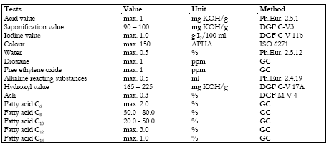

Form liquid
Colour yellow
pH no data available
Boiling point/range no data available
Flash point 254 °C
Density ca. 1.1 g/cm3; 20 °C
Water solubility 20 °C; completely miscible
Viscosity, dynamic 150 mPas; 20 °C

Turgut Özal Cad. No:121 41435 Gebze-Kocaeli/Turkey Tel:+90 262 658 07 70 Fax:+90 262 658 97 70
info@kalekimya.com www.kalekimya.com

